Case 2-Afr-Egy-Statue-Ptah-Chlorite-Dynasty 18-1390-1322 BCE

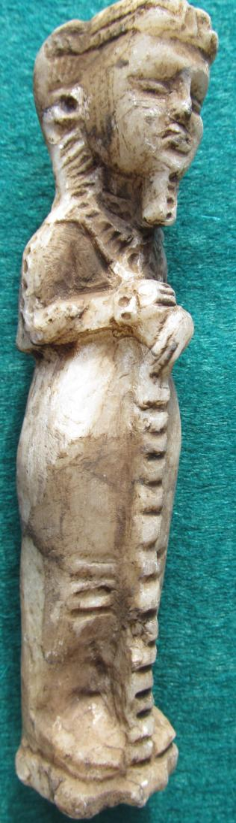 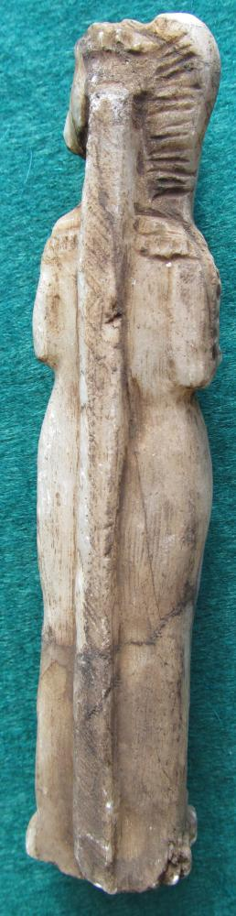 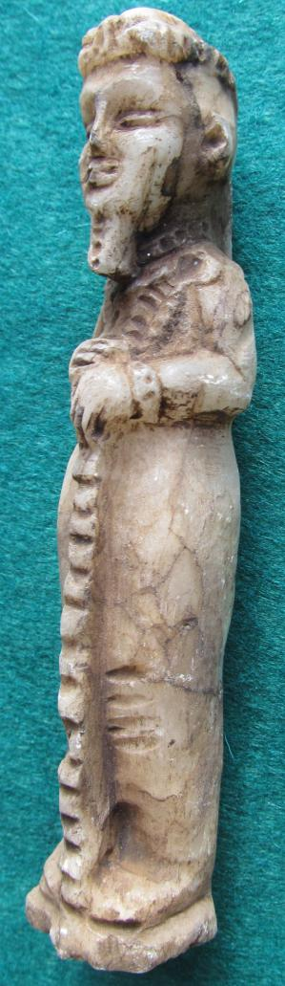

Figurine of Ptah, Memphis, Dynasty 18, reign of Amenhotep III - Tutankhamun (1390-1322 BCE)

BL2450.P7

Statuette of Ptah

Height:

Weight:

Ptah, god of craftsmen, was father of Nefertum and Imhotep. Nefertum was represented both the first sunlight and the emerging blue lotus flower ([*Nymphaea caerulea*](https://en.wikipedia.org/wiki/Nymphaea_caerulea)) from the primal waters. Imhotep was regarded also as the god of craftsmen and architects (a knowledge passed on from Ptah) and who was subsequently regarded as the earliest known architect and engineer *in* history. Imhotep was king Djoser’s architect of the Step Pyramid, which was built ca. 2650–2600 BCE, and he was also high priest of the sun god Ra at Heliopolis. Ptah’s wife was Sekhmet the lioness-headed goddess. Here, Ptah is shown wearing a beard (divine symbol) and a single braid on his right side. He holds the djed, perhaps in this case an instrument of measurement as it is prominently grooved horizontally. Perhaps, this statuette was once the amulet of an Egyptian engineer. As the god of craftsmen, the Ptah cult spread throughout Egypt from the Old Kingdom onwards.

References

Kemp, Barry J. 2005. *Ancient Egypt*. London: Routledge.

Holmberg, Sandman. 1946. *The God Ptah*. Lund: C.W.K. Gleerup .

|  |
| --- |
| **Ralph J Coffman Jr**  149 Atlantic Ave  Swampscott MA 01907-2427  United States |

## Order details

|  |  |  |  |
| --- | --- | --- | --- |
| **Item title** | **Available actions** | **Shipping & handling (estimated delivery*)** | **Price** |

[Printer version](http://payments.ebay.com/ws/eBayISAPI.dll?ViewPaymentStatus&transid=0&userloginid=802-867&orderid=125303748018&printerversion=true&itemid=271104286471)

|  |  |  |
| --- | --- | --- |
| Seller: | [**Member id** antiquewd](http://myworld.ebay.com/antiquewd) ( [**Feedback Score Of** 1459](http://feedback.ebay.com/ws/eBayISAPI.dll?ViewFeedback&userid=antiquewd)) | [Contact seller](http://contact.ebay.com/ws/eBayISAPI.dll?ShowCoreAskSellerQuestion&frm=3998&iid=0&redirect=0&requested=antiquewd) |

|  |
| --- |
| **Order # 125303748018**  Paid on Nov-18-12 via PayPal |

**antiquewd**

[**Member id** antiquewd](http://myworld.ebay.com/antiquewd/&_trksid=p3984.m1439.l2754) | [**Feedback Score Of** 1459](http://feedback.ebay.com/ws/eBayISAPI.dll?ViewFeedback2&userid=antiquewd&_trksid=p3984.m1439.l2776) | 98.5%

**Total items :** 17

$541.62

+$40.00

shipping

|  |
| --- |
| [More actions](javascript:;) |

**Egyptian stone style statue figure**



[Egyptian stone style statue figure](http://www.ebay.com/itm/271104337269?ssPageName=STRK:MEWNX:IT&_trksid=p3984.m1439.l2649) (271104337269)

Your max bid: $66.00

Sale date: 11/18/12

Tracking number: --

Estimated Delivery: 11/21/12 - 11/26/12

$20.50

**Paid with PayPal on November 18, 2012.**

**Not shipped**

**Feedback not left**

**Feedback not received**

|  |
| --- |
| [**Leave feedback**](http://feedback.ebay.com/ws/eBayISAPI.dll?LeaveFeedbackShow&useridto=antiquewd&item=271104337269&transactID=0&ssPageName=STRK:MEWNX:LF&_trksid=p3984.m1439.l2665) |
| [Sell this item](http://cgi5.ebay.com/ws/eBayISAPI.dll?SellLikeItem&item=271104337269&ssPageName=STRK:MEWNX:LILT&_trksid=p3984.m1439.l2667) |
| [More actions](javascript:;) |